20th June 2017

FIA European Touring Car Cup goes to Portugal

The FIA ETCC with Japanese Tyre manufacture YOKOHAMA as exclusive tyre supplier will visit Portugal at the weekend 24-25th June. With three race weekends already gone, Italy, Hungary and Germany, the next race weekend could create some distance between the two main contenders who are facing off in an impressive head to head and only separated by a 1 point difference. At the half way stage of the season, the Swiss driver Schreiber is leading the veteran Czech Fulin.

The expectation at Vila Reals street circuit is also to see local racers Mota and Rodrigues promising thrills and spills and hoping to benefit from crown support for a taste of home success in the streets of northern Portugal.

An action-packed weekend is in store and while the Nürburgring Nordschleife is rated as the toughest track on the planet, the 4.785-kilometre Vila Real street track is known affectionately as the Nürburgring Nordschleife of the South due to its similar blend of blind turns, climbs, descents and unforgiving nature. And like its German counterpart, fans visit Vila Real Real in their thousands making for a memorable weekend of touring car racing when the other ETCC regulars will be hoping to make an impact.

ETCC Current Standings:

1 Christjohannes Schreiber Switzerland 44
2 Petr Fulin Czech Republic 43
3 Igor Stefanovski Macedonia 33

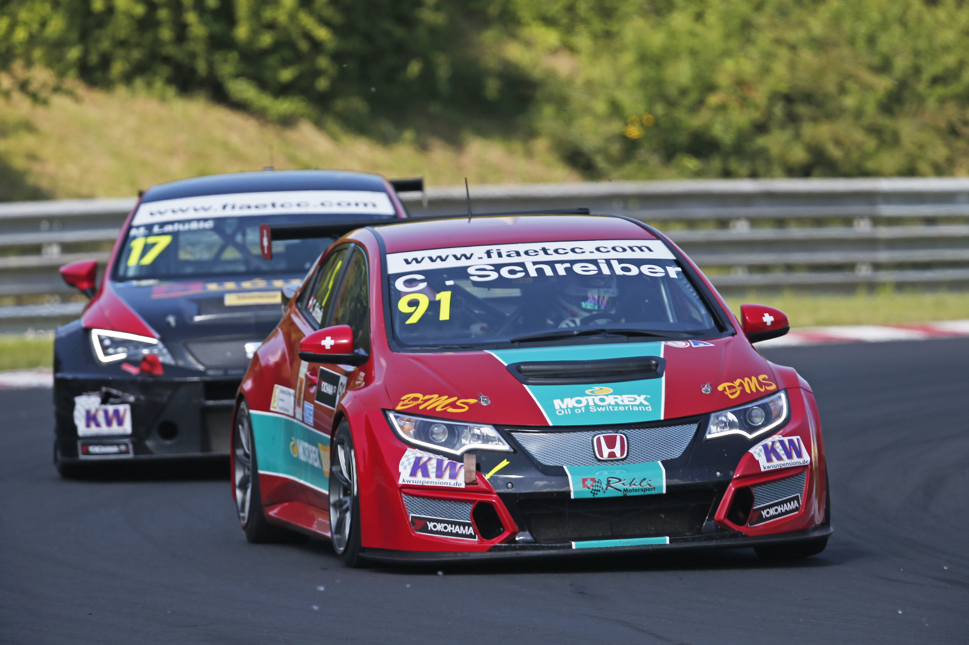
Schreiber leads ETCC by 1 point

